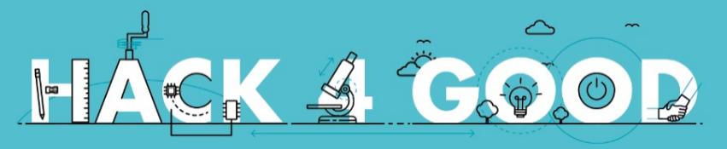

**CODE OF CONDUCT**

All attendees, sponsors, partners, volunteers and staff at our hackathon are required to agree with the following code of conduct. Organisers will enforce this code throughout the event. We expect cooperation from all participants to ensure a safe environment for everybody.

The Quick Version

Our hackathon is dedicated to providing a harassment-free experience for everyone, regardless of gender, gender identity and expression, age, sexual orientation, disability, physical appearance, body size, race, ethnicity, nationality, religion, previous hackathon attendance or computing experience (or lack of any of the aforementioned). We do not tolerate harassment of hackathon participants in any form. Sexual language and imagery is not appropriate at any hackathon venue, including hacks, talks, workshops, parties, social media and other online media. Hackathon participants violating these rules may be sanctioned or expelled from the hackathon at the discretion of the hackathon organisers.

The Less Quick Version

Harassment includes offensive verbal comments related to gender, gender identity and expression, age, sexual orientation, disability, physical appearance, body size, race, ethnicity, nationality, or religion, sexual images in public spaces, deliberate intimidation, stalking, following, photography or audio/video recording against reasonable consent, sustained disruption of talks or other events, inappropriate physical contact, and unwelcome sexual attention.

Photography is encouraged, but other participants must be given a reasonable chance to opt out from being photographed. If they object to the taking of their photograph, comply with their request. It is inappropriate to take photographs in contexts where people have a reasonable expectation of privacy.

Participants asked to stop any harassing behaviour are expected to comply immediately.

As this is a hackathon, we like to explicitly note that the hacks created at our hackathon are equally subject to the anti-harassment policy.

If you are being harassed, notice that someone else is being harassed, or have any other concerns, please contact a member of hackathon staff immediately.

Hackathon staff will be happy to help participants contact any local campus security, provide escorts or otherwise assist those experiencing harassment to feel safe for the duration of the hackathon. We value your attendance.

If a participant engages in harassing behaviour, the hackathon organisers may take any action they deem appropriate. This includes warning the offender, expulsion from the hackathon or reporting their behaviour to local law enforcement.

We expect participants to follow these rules at hackathon and workshop venues and hackathon-related social events.